

**Experiment vi: ALU**

**Objective:**

1. To implement ALU using VHDL

**Theory:**

The Arithmetic Logic Unit (ALU) is the heart of any CPU. An ALU performs three kinds of operations, i.e.

* Arithmetic operations such as Addition/Subtraction,
* Logical operations such as AND, OR, etc. and
* Data movement operations such as Load and Store

ALU derives its name because it performs arithmetic and logical operations. A simple ALU design is constructed with Combinational circuits. ALUs that perform multiplication and division are designed around the circuits developed for these operations while implementing the desired algorithm. It is basically the actual data processing element within the central processing unit (CPU) in a computing system. It performs all the arithmetic and logical operations and forms the backbone of modern computer technology.

**Architecture:**

**--**design for alu

library IEEE;

use IEEE.STD_LOGIC_1164.ALL;

use IEEE.STD_LOGIC_UNSIGNED.ALL;

use ieee.NUMERIC_STD.all;

entity ALU is

generic ( constant N: natural:=1); -- number of shifted or rotated bits

Port (

A, B: in STD_LOGIC_VECTOR (7 downto 0); -- 2 inputs 8-bit

ALU_Sel: in STD_LOGIC_VECTOR (3 downto 0); -- 1 input 4-bit for selecting function

ALU_Out: out STD_LOGIC_VECTOR (7 downto 0); -- 1 output 8-bit

Carryout: out std_logic; -- Carryout flag

);

end ALU;

architecture Behavioral of ALU is

signal ALU_Result: std_logic_vector (7 downto 0);

signal tmp: std_logic_vector (8 downto 0);

begin

process(A,B,ALU_Sel)

begin

case(ALU_Sel) is

when "0000" => -- Addition

ALU_Result <= A + B ;

when "0001" => -- Subtraction

ALU_Result <= A - B ;

when "0010" => -- Multiplication

ALU_Result<=std_logic_vector(to_unsigned((to_integer(unsigned(A)) *

to_integer(unsigned(B))),8)) ;

when "0011" => -- Division

ALU_Result <= std_logic_vector(to_unsigned(to_integer(unsigned(A)) /

to_integer(unsigned(B)),8)) ;

when "0100" => -- Logical shift left

ALU_Result <= std_logic_vector(unsigned(A) sll N);

when "0101" => -- Logical shift right

ALU_Result <= std_logic_vector(unsigned(A) srl N);

when "0110" => -- Rotate left

ALU_Result <= std_logic_vector(unsigned(A) rol N);

when "0111" => -- Rotate right

ALU_Result <= std_logic_vector(unsigned(A) ror N);

when "1000" => -- Logical and

ALU_Result <= A and B;

when "1001" => -- Logical or

ALU_Result <= A or B;

when "1010" => -- Logical xor

ALU_Result <= A xor B;

when "1011" => -- Logical nor

ALU_Result <= A nor B;

when "1100" => -- Logical nand

ALU_Result <= A nand B;

when "1101" => -- Logical xnor

ALU_Result <= A xnor B;

when "1110" => -- Greater comparison

if(A>B) then

ALU_Result <= x"01" ;

else

ALU_Result <= x"00" ;

end if;when "1111" => -- Equal comparison

if(A=B) then

ALU_Result <= x"01" ;

else

ALU_Result <= x"00" ;

end if;

when others => ALU_Result <= A + B ;

end case;

end process;

ALU_Out <= ALU_Result; -- ALU out

tmp <= ('0' & A) + ('0' & B);

Carryout <= tmp(8); -- Carryout flag

end Behavioral;

**Source code:**

-- Testbench for alu adder

library IEEE;

use IEEE.std_logic_1164.all;

entity testbench is

-- empty

end testbench;

architecture tb of testbench is

-- DUT component

component ALU is

Port (

A, B: in STD_LOGIC_VECTOR (7 downto 0); -- 2 inputs 8-bit

ALU_Sel: in STD_LOGIC_VECTOR (3 downto 0); -- 1 input 4-bit for selecting function

ALU_Out: out STD_LOGIC_VECTOR (7 downto 0); -- 1 output 8-bit

Carryout: out std_logic; -- Carryout flag

);

end component;

signal A, B: std_logic_vector(7 downto 0);

signal ALU_Sel: std_logic_vector(3 downto 0);

signal ALU_out: std_logic_vector(7 downto 0);

signal Carryout: std_logic;

begin

-- Connect DUT

DUT: ALU

port map (

A => A,

B => B,

ALU_Sel => ALU_Sel,

ALU_out => ALU_out,

Carryout => Carryout

);

-- Test process

process

begin

-- Test cases

A <= "00001111";

B <= "00001100";

ALU_Sel<= "0000";

wait for 10 ns; -- Expected output: S_out = "0000", Cout_out = '0'

A <= "00001011";

B <= "00000110";

ALU_Sel <= "0001";

wait for 10 ns; -- Expected output: S_out = "0010", Cout_out = '0'

A <= "00000100";

B <= "00000011";

ALU_Sel <= "0010";

wait for 10 ns;

A <= "00001000";

B <= "00000100";

ALU_Sel <= "0011";

wait for 10 ns;

-- End of simulation

wait for 20 ns;

assert false report "End of simulation" severity failure;

end process;

end tb;

**Output:**

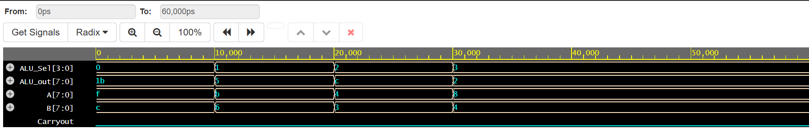

**Conclusion:**

In conclusion, designing an ALU in VHDL enables efficient implementation of arithmetic and logic operations in digital systems. VHDL's flexibility and modularity allow for easy testing, simulation, and refinement, ensuring reliable performance. It is a powerful tool for creating high-performance, cost-effective hardware designs.

**Experiment vii: 3-Segment Pipeline**

**Objective:**

1. To implement 3-Segment Pipeline using VHDL

**Theory:**

A 3-segment instruction pipeline in computer architecture divides instruction processing into three stages: fetch, decode, and execute. To perform tasks such as fetching, decoding and execution of instructions, most digital computers with complicated instructions would require an instruction pipeline.

In general, each and every instruction must be processed by the computer in the following order:

1. Fetching the instruction from memory

2. Decoding the obtained instruction

3. Calculating the effective address

4. Fetching the operands from the given memory

5. Execution of the instruction

6. Storing the result in a proper place

**Architecture:**

--design for pipeline

library IEEE;

use IEEE.STD_LOGIC_1164.ALL;

use IEEE.NUMERIC_STD.ALL;

entity pipeline is

Port (

a : in integer;

b : in integer;

c : in integer;

clk : in STD_LOGIC;

y : out integer

);

end pipeline;

architecture Behavioral of pipeline is

signal r1, r2, r3, r4, r5 : integer := 0;

begin

y <= r5;

process(clk)

begin

if rising_edge(clk) then

-- Pipeline stage 1

r1 <= a;

r2 <= b;

-- Pipeline stage 2 (registered)

r4 <= r1 + r2;

r3 <= c;

-- Pipeline stage 3 (registered)

r5 <= r4 * r3;

end if;

end process;

end Behavioral;

**Source code:**

--testbench for pipeline

library IEEE;

use IEEE.STD_LOGIC_1164.ALL;

use IEEE.NUMERIC_STD.ALL;

entity pipeline_tb is

end pipeline_tb;

architecture Behavioral of pipeline_tb is

component pipeline

Port (

a : in integer;

b : in integer;

c : in integer;

clk : in STD_LOGIC;

y : out integer

);

end component;

signal a, b, c : integer := 0;

signal y : integer;

signal clk : STD_LOGIC := '0';

constant clk_period : time := 10 ns;

begin

uut: pipeline port map (

a => a,

b => b,

c => c,

clk => clk,

y => y

);

-- Clock generation

clk_process: process

begin

clk <= '0';

wait for clk_period/2;

clk <= '1';

wait for clk_period/2;

end process;

-- Stimulus process

stim_proc: process

begin

-- Test case 1

a <= 2;

b <= 3;

wait for 3 ns;

c <= 4;

wait for clk_period*2;

-- Test case 2

a <= 5;

b <= 6;

wait for 5 ns;

c <= 7;

wait for clk_period*2;

-- Test case 3

a <= 10;

b <= 20;

wait for 5 ns;

c <= 30;

wait for clk_period*2;

-- End simulation

wait;

end process;

end Behavioral;

**Output:**

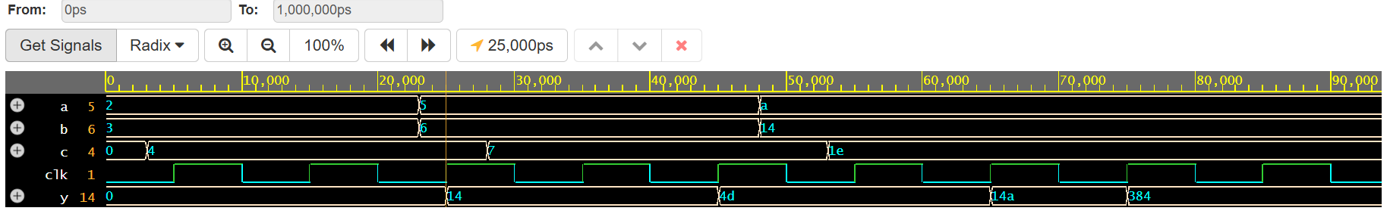

**Conclusion:**

In conclusion, implementing a 3-segment pipeline in VHDL enhances system performance by allowing parallel processing of data in stages. This approach increases throughput and reduces latency by efficiently organizing tasks across different pipeline segments. VHDL provides the necessary tools to model, simulate, and optimize the pipeline, ensuring smooth operation and scalability in complex digital systems.